Multiple-choice section – choose the correct answer

Question 1 [9.5]

Which one of the following statements is false?

A A parallelogram has two pairs of parallel sides.

B A kite has opposite sides equal.

C The diagonals of a rhombus bisect each other at right angles.

D A square is a special type of rectangle.

Question 2 [9.1]

Which is not a test for congruent triangles?

A SSS B AAA C RHS D ASA

Question 3 [9.1]

The value of x in the pair of similar triangles is:

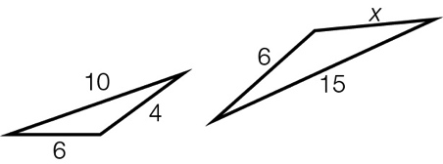

A 4 B 12 C 8 D 9

Question 4 [9.2]

with can be used as part of a test for congruency because:

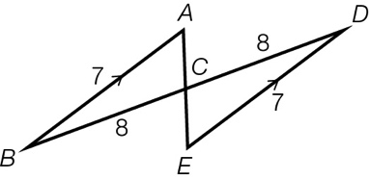

A they are alternate angles

B they are opposite angles

C their sum is 180º

D they are both acute angles

Question 5 [9.3, 9.5]

If OB = OC, which congruency test can be used to prove ≡?

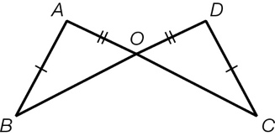

A SAS B ASA C RHS D SSS

Question 6 [9.2]

A pair of congruent triangles is:

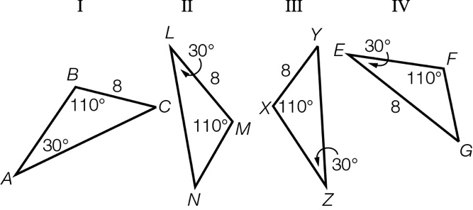

A II and III B I and IV C I and III D II and IV

Question 7 [9.4]

Which statement is false for the diagram shown?

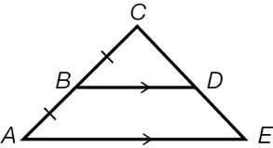

A  B 

C  D 

Question 8 [9.6] [10A]

What is the value of ?

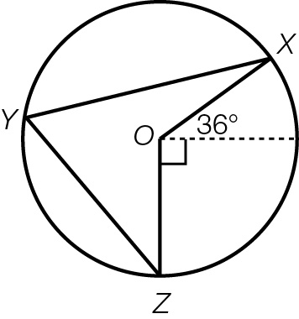

A 72° B 18° C 36° D 63°

Multiple-choice total marks: ____ / 8

Short answer section

Question 9 2 marks [9.1, 9.2]

Use words from the list below to complete the following sentences.

bisect included angle definition perpendicular bisector

congruent similar theorem perpendicular

(a) An angle of  at the point of intersection of two lines means they are   
____________________.

(b) Two equilateral triangles of different side lengths are _____________ in shape.

Question 10 2 marks [9.2]

Explain the term ‘perpendicular bisector’. Use a diagram to help with your explanation.

Question 11 4 marks [9.1]

In , and.

In .

(a) Explain why the two triangles are similar.

(b) What is the value of DF?

Question 12 2 marks [9.2]

Explain why testing two triangles for AAA does not guarantee congruency.

Question 13 3 marks [9.1]

Calculate the values of x and y if the pair of triangles shown are similar.

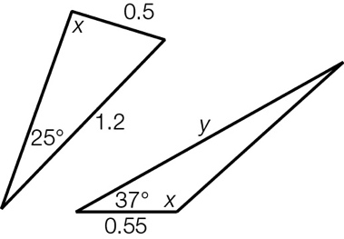

Question 14 3 marks [9.1]

The small triangles in the diagram are all equilateral.

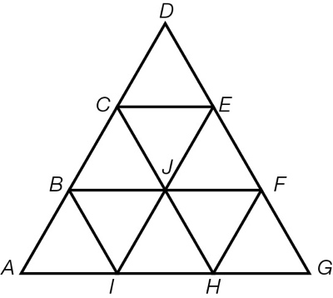

(a) Name two different-sized triangles that are similar to .

(b) Name two parallelograms that are congruent to ABFH.

(c) Name a shape that is congruent to BCEFHJ.

Question 15 3 marks [9.3]

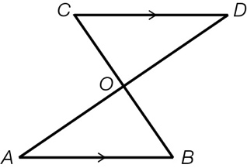

Prove that is similar to .

Question 16 5 marks [9.2]

A rectangular garden of dimensions 5 m × 1.4 m has been expanded proportionally so that the  
width is now 2.1 m.

(a) If the old garden shape and the new shape are similar figures, what is the length of the new garden?

(b) The garden will be enlarged again, with the new length being 12.5 m. What will be the width of the garden now?

(c) What dilation factor has been applied to enlarge the original garden to its final size?

Question 17 3 marks [9.3]

Show that when .

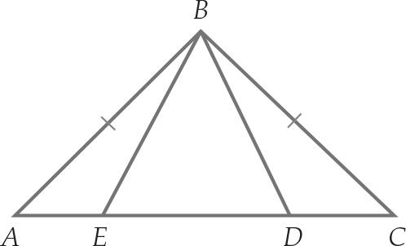

Question 18 3 marks [9.2]

A ladder rests on a 1.5 m wall with one end against a tree at a height of 5 m above the ground and the other end on the ground. If the wall is 0.5 m from the bottom of the ladder, find the:

(a) horizontal distance, in metres correct to 2 decimal places, of the base of the ladder from the bottom of the tree

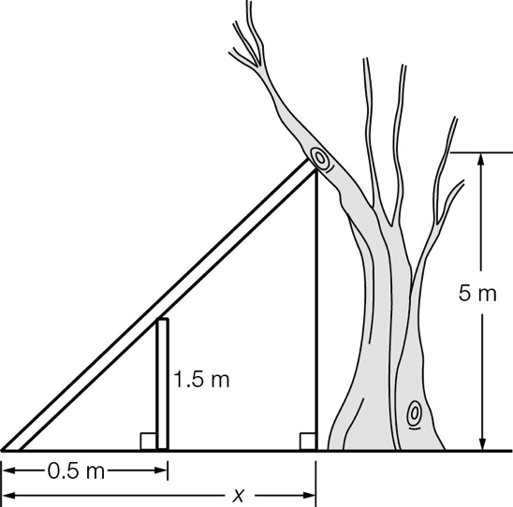

(b) horizontal distance, in metres correct to 2 decimal places, of the wall from the bottom of the tree.

Short answer total:_____ /30

Extended answer section

Question 19 5 marks [9.3]

 and  are different-sized equilateral triangles.

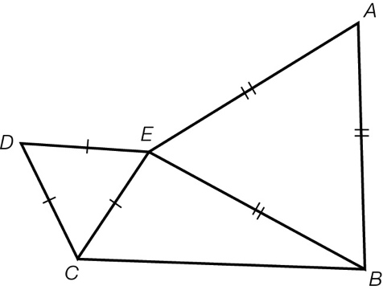

(a) Show that .

(b) Show that .

(c) Hence, show that BD = AC.

Question 20 8 marks [9.2, 9.3]

In the diagram, AC = EC and BC = DC.

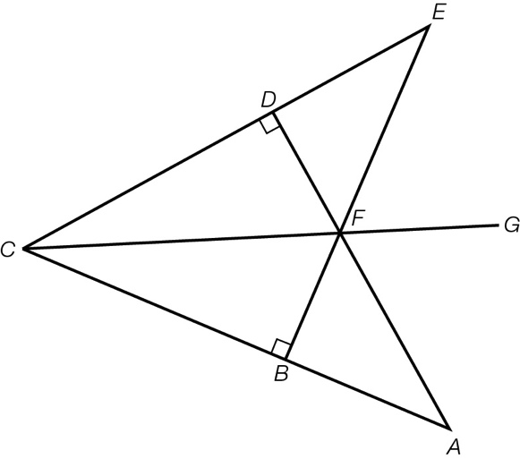

(a) Prove that 

(b) Prove that 

(c) Prove that CG bisects 

Question 21 6 marks [9.3]

 is an isosceles triangle, where AB = BC and D is the midpoint of AC.

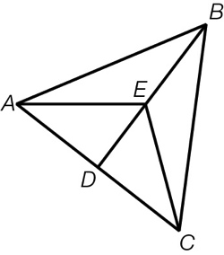

(a) Prove that .

(b) Prove that .

(c) Prove that .

Question 22 4 marks [9.6] [10A]

Point O is the centre of the circle. Show that:

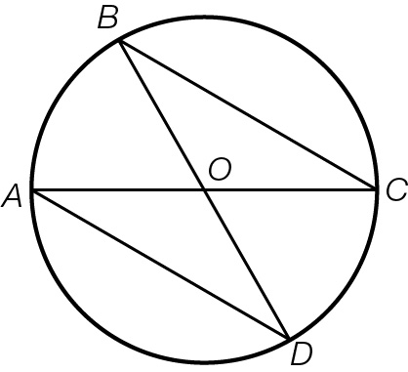

(a) 

(b) 

Extended answer total: ______ /23

TOTAL test results: ______ / 61